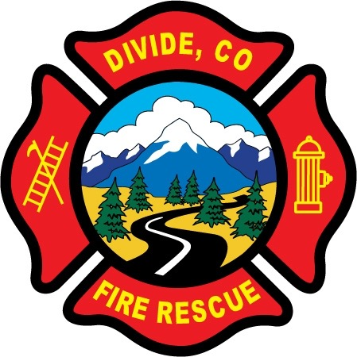

DIVIDE FIRE PROTECTION DISTRICT

Board of Directors Meeting

Shoemaker Fire Station, 103 Cedar Mountain Road (Mail: PO Box 941), Divide Colorado, 80814

July 14th, 2020 at 6:00 p.m.

MINUTES OF THE REGULAR MEETING

Special Note: The meeting was conducted at Station 1 with access for the public via Zoom. Notice of this change and instructions how to access the meeting through Zoom was posted on the district website and shared through Facebook.

- Call to Order
President Shoemaker called to order the regular meeting of the Board of Directors of the Divide Fire Protection District (DFPD) at 6:05 p.m.

Attendance

Board members present:
Candy Shoemaker – President
Josh Weatherill – Vice President
Allison Mosser – Treasurer
Barry Pleshek – Secretary
Dennis Luttrell – Director

2. Review and Approve Agenda
Motion by Director Mosser to approve the agenda. Second by Director Weatherill. The motion passed unanimously.

3. Review, Approve, and Sign Minutes of Prior Meeting
Motion by Director Luttrell to approve the minutes of the previous board meeting. Second by Director Pleshek. The motion passed unanimously.

4. Public Comment – none.

5. Financial Matters
A. Financial Reports – attached. It was noted that legal fees are over budget and will probably increase further by year-end.
B. Purchase Orders – 2020-08 – PK Safety – 4 gas meter - $859 plus shipping
Motion by Director Luttrell to approve the financials and the purchase order. Second by Director Weatherill. The motion passed unanimously.
C. Credit Cards
Director Mosser will cancel all wildland related credit cards except for members Ryan Kennedy and Tyler Knowlton. Motion by Director Weatherill to increase Diana Perkins’ card limit to $2000 to accommodate her additional position as Administrative Manager. Second by Director Mosser. The motion passed unanimously.

7. Chief’s Report – Attached. Members would like to still hold the annual Pancake Breakfast, but procedures are uncertain at this point due to rapidly changing public health limitations. This topic will continue to be discussed by the members.

- Board Business Meeting Attendees – Directors Weatherill and Mosser will attend the next business meeting on August 3rd, at 7 p.m. Director Luttrell will be backup.

8. Administrator Report – attached.

9. Old Business

- Policies
  - Financial Policies – In Progress.

  - Updates to Handbook
    - Marijuana/Drugs – Director Mosser submitted a draft to review.
    - Security Camera – In progress.
    - Training Requirements – In progress.
    - Harassment/Discrimination
Director Weatherill reported to the board that there was some concern/confusion among the members about section 2.4.3 of the handbook regarding the circumstances that would require an outside investigator to conduct an investigation. In order to trigger an outside investigation, the complaint must meet the definitions in sections 2.2 and 2.3 of unlawful/illegal harassment or discrimination. This section of the handbook will be modified in coordination with legal counsel to clarify this issue, along with other sections needing update. Director Shoemaker will draft a brief explanatory email to the department to address the concerns. It was also discussed that it was appropriate for the District employees to sign a Handbook Acknowledgement, but not the District board members. Although the handbook contains language involving board actions, the board is governed primarily by state statute (Title 32 for Special Districts) and the District’s own Board Policies.

- Station Security – No issues during the month.

- Brush Truck – This item is completed.

- Five Year Plan – In progress.

- Emergency Plan – Diana Perkins and Director Shoemaker will be attending an online webinar on this topic, and continue to gather information.

- Air/Light Trailer Agreement – Director Luttrell met with OEM Director Don Angell, who requested that Divide Fire provide the first draft of the agreement. Angell understands no maintenance is being performed on the trailer in the meantime. The board agrees the easiest solution would be for the trailer to be signed over to Divide Fire. The trailer could then be insured by the District and its usage by other departments would be covered under mutual aid agreements. Director Luttrell would like input on the agreement in the next week. He will also pursue getting a copy of the original grant the County received to purchase the trailer, to examine any requirements included.

10. New Business
A. Audit – Diana Perkins reported that the draft review of the audit will be submitted soon, but will not be able to be reviewed in time to meet the statutory deadline of July 31st. Director Mosser signed an extension request that the auditors will submit to the state.

11. Adjournment

Motion by Director Pleshek to adjourn the meeting. Second by Director Mosser. The motion passed unanimously. The meeting was adjourned at 8:28 p.m. The next regular meeting will take place on Tuesday, August 11th, at 6:00 p.m.

APPROVAL

We attest that the foregoing minutes, which have been approved by the affirmative majority vote of the Board of Directors of the Divide Fire Protection District, are a true and accurate record of the meeting held on the date stated above.

__________________________________________________ ______/______/_______
Name and Title Date

__________________________________________________ ______/______/_______
Name and Title Date

