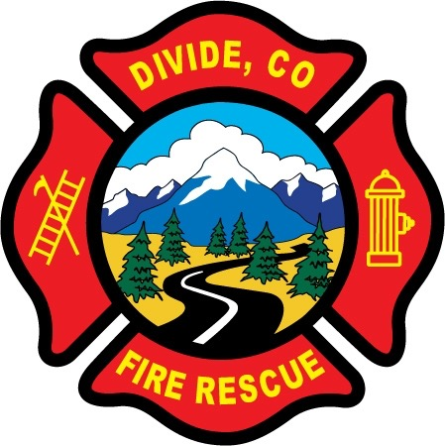

DIVIDE FIRE PROTECTION DISTRICT

Board of Directors Meeting

Shoemaker Fire Station, 103 Cedar Mountain Road (Mail: PO Box 941), Divide Colorado, 80814

August 10th, 2021 at 6:00 p.m.

MINUTES OF THE REGULAR MEETING

- Call to Order
Vice-President Josh Weatherill called to order the regular meeting of the Board of Directors of the Divide Fire Protection District (DFPD) at 6:00p.m.

Attendance

Board members present:
Josh Weatherill – Vice President
Allison Mosser – Treasurer
Barry Pleshek – Secretary
Dennis Luttrell – Director

Board members absent:
Candy Shoemaker – President

2. Review and Approve Agenda
Motion by Director Luttrell to approve the agenda. Second by Director Mosser. The motion passed unanimously.

3. Review, Approve, and Sign Minutes of Prior Meeting
Motion by Director Pleshek to approve the minutes of the previous board meeting. Second by Director Luttrell. The motion passed unanimously.

4. Public Comment – None.

5. Financial Matters
A. Financial Reports – attached. Motion by Director Mosser to approve the financials and pay bills. Second by Director Luttrell. The motion passed unanimously.
B. Purchase Orders – 2021-10 Chrisbens - $1000 – POV car repairs
Motion by Director Luttrell to approve the purchase order. Second by Director Mosser. The motion passed unanimously.

6. Chief’s Report – attached.
A. Business Meeting Attendees – Director Pleshek will attend the August 30th business meeting with Director Mosser as backup.

7. Administrator Report – attached. Diana Perkins submitted a list of vehicles with vendor requirements for various services. Chief Kennedy reported that the County is closer to taking action to establish a large vehicle service center. The board would like to support this endeavor any way possible. Perkins also updated the board on compliance issues and vehicle driving/safety issues. Regarding the required HR training, the board agreed to offer a one-month grace period until August 31st, after which anyone non-compliant will be placed on administrative leave. The board also agreed to adjust the wording regarding Handbook compliance to eliminate the annual Handbook Acknowledgment form for existing members. Perkins will coordinate closely with Chief Kennedy regarding this topic.

8. Old Business

- Policies
  - Updates to Handbook – Ireland Stapleton submitted a draft version which Director Mosser emailed to board members prior to the meeting. The board will review this draft in order to discuss at the next meeting. Director Weatherill submitted a quote from Lexipol at the meeting. Director Mosser will get feedback from Ireland Stapleton on Lexipol.

- Station Security – No reports of security issues.

- Air/Light Trailer Agreement – Director Shoemaker sent a letter to the Teller County Board of Commissioners. She received feedback that this topic should be discussed in person with Cheryl Deckers before it becomes a Board of Commissioners issue. She is waiting to hear back from Deckers.

- Audit – The auditors filed an extension request and the draft audit should be submitted to Divide in the next few days.

9. New Business – none.

10. Executive Session – none.

Adjournment

Motion by Director Mosser to adjourn the meeting. Second by Director Pleshek. The motion passed unanimously. The meeting was adjourned at 7:42 p.m. The next regular meeting will take place on Tuesday, September 14th, at 6:00 p.m.

APPROVAL

We attest that the foregoing minutes, which have been approved by the affirmative majority vote of the Board of Directors of the Divide Fire Protection District, are a true and accurate record of the meeting held on the date stated above.

__________________________________________________ ______/______/_______
Name and Title Date

__________________________________________________ ______/______/_______
Name and Title Date

