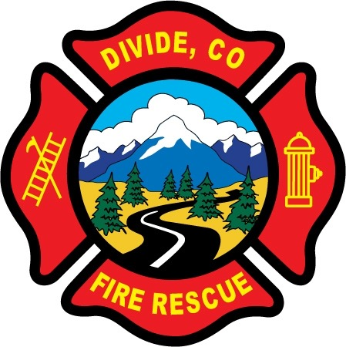

DIVIDE FIRE PROTECTION DISTRICT

Board of Directors Meeting

Shoemaker Fire Station, 103 Cedar Mountain Road (Mail: PO Box 941), Divide Colorado, 80814

February 8th, 2022 at 6:00 p.m.

MINUTES OF THE REGULAR MEETING

1. Call to Order
President Candy Shoemaker called to order the regular meeting of the Board of Directors of the Divide Fire Protection District (DFPD) at 6:03 p.m.

Attendance
Board members present:
Candy Shoemaker – President
Josh Weatherill – Vice President
Allison Mosser – Treasurer
Barry Pleshek – Secretary
Dennis Luttrell – Director

2. Review and Approve Agenda
Motion by Director Luttrell to approve the agenda. Second by Director Mosser. The motion passed unanimously.

3. Review, Approve, and Sign Minutes of Prior Meeting
Motion by Director Mosser to approve the minutes of the previous board meeting. Second by Director Luttrell. The motion passed unanimously. Motion by Director Mosser to approve the minutes of the special meeting on February 1st, 2022. Second by Director Luttrell. The motion passed unanimously.

4. Public Comment – no comment.

5. Pension Board Meeting– Director Mosser called the Pension Board meeting to order at 6:05 pm. Present were all Board members listed above and Ryan Kennedy, member-at-large. James Wells member-at-large was not present Motion by Ryan Kennedy to accept the 2021 pension credits as submitted to FPPA. Second by Director Pleshek. The motion passed unanimously. Motion by Director Shoemaker to adjourn the meeting. Second by Ryan Kennedy. The motion passed unanimously and the Pension Board meeting was adjourned at 6:14 p.m.

6. Financial Matters
A. Financial Reports – attached.
B. Purchase Orders – none.
Motion by Director Luttrell to approve the financials. Second by Director Mosser. The motion passed unanimously. See additional financial matter under section 8, EMTS Grant.

7. Chief’s Report – attached.
A. Wildland Policy – The board asked that the deployment credit card be added to this policy.
C. Business Meeting Attendees – Director Mosser March 7th business meeting, with Director Pleshek as backup.

8. Administrator Report – attached.
a. IGA Agreement – Motion by Director Weatherill to enter the IGA agreement with Northeast Teller County Fire for vehicle repairs. Second by Director Mosser. The motion passed unanimously.
b. EMTS Grant – Perkins submitted the intention to the Board to apply for extrication equipment and (30) 800mhz radios via the EMTS grant. Additional matching funds needed for this request will come from budget line item 5657, previously allocated for a REMS vehicle. Chief Buckley was present and confirmed that the officers supported the re-allocation of these funds for those purposes. The Board supported submitting the EMTS Grant request.

9. Old Business

- Policies
  - Updates to Handbook
    - Legal Clarification of Public Records – Director Mosser requested approval of the Board to consult legal counsel regarding our public record policy and confidential file procedures. See motion below.
    - A Special Meeting for a Handbook work session will be held on Tuesday, February 15th, 2022 at 5:30 p.m.

- Station Security – Director Weatherill reported a request from the Sheriff’s Office for security video during possibly criminal activity on CR 51 in front of the station. He questioned whether the District would need a subpoena to share that. Motion by Director Luttrell to consult with legal counsel regarding the security tape request and the District’s public record and confidential file procedures. Second by Director Pleshek. The motion passed unanimously.

- New Engine – Director Mosser shared proposals for financing at five, six, and seven year terms. Motion by Director Pleshek to adopt a resolution authorizing Director Mosser to secure financing according to the terms indicated in the six year proposal. Second by Director Luttrell. The motion to adopt the resolution passed unanimously.

- Election – Diana Perkins reported the call for nominations was posted on the District’s website and Facebook page, and was being run in the Courier according to statute. Self Nomination forms are available.

10. New Business – none.

11. Executive Session – none.

12. Adjournment

Motion by Director Weatherill to adjourn the meeting. Second by Director Mosser. The motion passed unanimously. The meeting was adjourned at 7:52 p.m. The next regular meeting will take place on Tuesday, March 8th, 2022 at 6:00 p.m. There will be a Special Meeting on Tuesday, February 15th, 2022, at 5:30 p.m.

APPROVAL

We attest that the foregoing minutes, which have been approved by the affirmative majority vote of the Board of Directors of the Divide Fire Protection District, are a true and accurate record of the meeting held on the date stated above.

__________________________________________________ ______/______/_______
Name and Title Date

__________________________________________________ ______/______/_______
Name and Title Date

