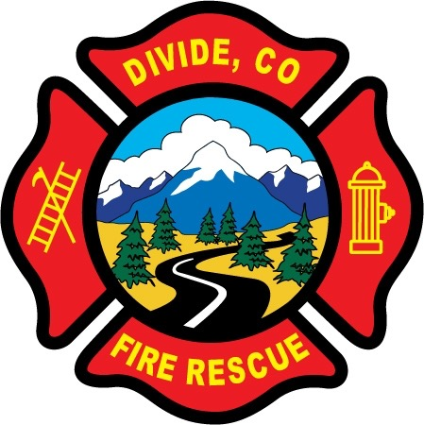

DIVIDE FIRE PROTECTION DISTRICT

Board of Directors Meeting

Shoemaker Fire Station, 103 Cedar Mountain Road (Mail: PO Box 941), Divide Colorado, 80814

April 13th, 2021 at 6:00 p.m.

MINUTES OF THE REGULAR MEETING

Special Note: Public Access was via Zoom. Notice and instructions how to access the meeting through Zoom was posted on the district website and shared through Facebook.

- Call to Order
President Candy Shoemaker called to order the regular meeting of the Board of Directors of the Divide Fire Protection District (DFPD) at 18:09.

Attendance

Board members present:
Candy Shoemaker – President
Josh Weatherill – Vice President
Allison Mosser – Treasurer
Barry Pleshek – Secretary
Dennis Luttrell – Director

2. Review and Approve Agenda
Motion by Director Luttrell to approve the agenda. Second by Director Weatherill. The motion passed unanimously.

3. Review, Approve, and Sign Minutes of Prior Meeting
Motion by Director Luttrell to approve the minutes of the previous board meeting. Second by Director Weatherill. The motion passed unanimously.

4. Public Comment – None.

5. Financial Matters
A. Financial Reports – attached.
B. Purchase Orders – 2021-03 – Firehouse Innovations - $7565.00 - fire training door. This item was budgeted at $6000 plus $1000 shipping. The cost will be exceeded by $565.00.

Motion by Director Mosser to approve the purchase orders for the excess amount. The expense will also be moved to 5505 Training as a training related expense. Second by Director Weatherill. The motion passed unanimously. Motion by Director Pleshek to approve the financials. Second by Director Weatherill. The motion passed unanimously.

Fire Captain James Wells was present, and also discussed the sale of SCBAs. It was noted that the district needs to track which purchases are made with grant funds so that these items can be handled per contractual agreements when sold. Diana Perkins will check asset tag numbers to discern if any of the SCBAs to be sold were purchased with grant funds.

6. Chief’s Report – Not present.
A. Business Meeting Attendees – Director Luttrell will attend the May 3rd business meeting with Director Shoemaker as backup.

7. Administrator Report – attached. Missing radios were discussed, including the possibility of filing a police report.

8. Old Business

- Policies
  - Updates to Handbook
    - Disciplinary Policy – Ireland Stapleton submitted a draft for review. After much discussion of the draft, it was decided to table any Handbook changes until the entire Handbook can be subject to a legal review. Ireland Stapleton estimated $1500 to complete that process, but recommended waiting until late May due to possible legislative changes. Chief Kennedy will need to be included in a discussion about disciplinary enforcement as it relates to board-specified requirements.

- Station Security – No issues during the month.

- Air/Light Trailer Agreement – Director Luttrell submitted the agreement to Teller County but there has been no response yet.

- Parking Lot Asphalt – No updates.

9. New Business
A. Insurance Coverage / Associate Members – Diana Perkins explained that after multiple conversations with the district’s insurance underwriter it is clear that associate members who do not respond to calls are not covered under the worker’s compensation policy due to Colorado law. The members are covered under the Accident/Sickness Policy but only up to an amount of $25,000. General Liability coverage is limited by governmental immunity. Diana Perkins will advise members who are affected by this and will also make up a notification form. The board will investigate possibly raising the Acc/Sickness limitations to give more coverage.

10. Executive Session – none.

Adjournment

Motion by Director Mosser to adjourn the meeting. Second by Director Luttrell. The motion passed unanimously. The meeting was adjourned at 19:53. The next regular meeting will take place on Tuesday, May 11th, at 6:00 p.m.

APPROVAL

We attest that the foregoing minutes, which have been approved by the affirmative majority vote of the Board of Directors of the Divide Fire Protection District, are a true and accurate record of the meeting held on the date stated above.

__________________________________________________ ______/______/_______
Name and Title Date

__________________________________________________ ______/______/_______
Name and Title Date

