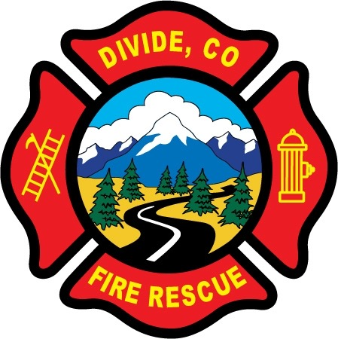

DIVIDE FIRE PROTECTION DISTRICT

Board of Directors Special Meeting

Shoemaker Fire Station, 103 Cedar Mountain Road (Mail: PO Box 941), Divide Colorado, 80814

March 1st, 2022, 5:30 p.m.

MINUTES OF THE SPECIAL MEETING

- Call to Order
President Candy Shoemaker called to order the special meeting of the Board of Directors of the Divide Fire Protection District (DFPD) at 5:37 p.m.

Board members present:
Candy Shoemaker – President
Allison Mosser – Treasurer
Barry Pleshek – Secretary
Josh Weatherill – Vice-President
Dennis Luttrell - Director

2. Review and Approve Agenda
The Notice has been properly posted with a copy of the Notice of Special Meeting and a copy of the Agenda. Motion by Director Mosser to approve the agenda. Second by Director Weatherill. The motion passed unanimously.

- Public Comment – none.

- Handbook – The board continued Handbook review and revisions. Motion by Director Mosser to pay Board members for Handbook meetings as allowed by Colorado statute. Second by Director Pleshek. The motion passed unanimously.

- Adjournment

Motion by Director Mosser to adjourn the meeting. Second by Director Luttrell. The motion passed unanimously. The meeting was adjourned at 7:44 p.m.

APPROVAL

We attest that the foregoing minutes, which have been approved by the affirmative majority vote of the Board of Directors of the Divide Fire Protection District, are a true and accurate record of the meeting held on the date stated above.

__________________________________________________ ______/______/_______
Name and Title Date

__________________________________________________ ______/______/_______
Name and Title Date

