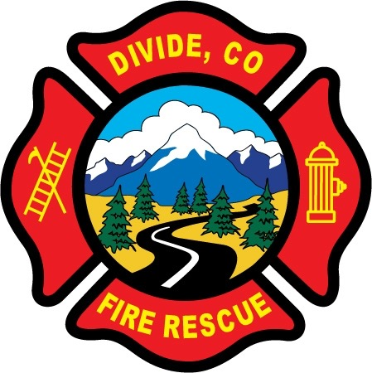

DIVIDE FIRE PROTECTION DISTRICT

Board of Directors Meeting

Shoemaker Fire Station, 103 Cedar Mountain Road (Mail: PO Box 941), Divide Colorado, 80814

June 8th, 2021 at 6:00 p.m.

MINUTES OF THE REGULAR MEETING

- Call to Order
President Candy Shoemaker called to order the regular meeting of the Board of Directors of the Divide Fire Protection District (DFPD) at 6:02p.m.

Attendance

Board members present:
Candy Shoemaker – President
Josh Weatherill – Vice President
Allison Mosser – Treasurer
Barry Pleshek – Secretary
Dennis Luttrell – Director

2. Review and Approve Agenda
Diana Perkins asked for “Audit” to be added under new business. Motion by Director Pleshek to approve the agenda with addition. Second by Director Weatherill. The motion passed unanimously.

3. Review, Approve, and Sign Minutes of Prior Meeting
Motion by Director Weatherill to approve the minutes of the previous board meeting. Second by Director Mosser. The motion passed unanimously.

4. Public Comment – None.

5. Financial Matters
A. Financial Reports – attached.
B. Purchase Orders – 2021-05 – Rapid Extrication Board - $650 – Note: This was presented again with the purchase now coming out of the Technical Rescue budget and approved by Tech Rescue Captain Mike Babiarz.

Motion by Director Luttrell to approve the financials and the purchase order. Second by Director Weatherill. The motion passed unanimously.

Chief Ryan Kennedy also requested a deployment credit card for Jesse Weatherill. Motion by Director Mosser to approve a credit card with a $5000 limit for Jesse Weatherill. Second by Director Luttrell. Director Weatherill abstained from the vote due to a personal relationship. The motion passed unanimously.

6. Chief’s Report – attached. Chief Kennedy reported the department BBQ will be held at Sourdough Ranch on August 15th. He also reported that the county sent out a flyer with Divide Fire dates for the chipper project, but it is not yet known if there will be any volunteers to staff the chipper. Diana Perkins confirmed there were no insurance issues associated with this project.

A. Business Meeting Attendees – Director Pleshek will attend the July 12th business meeting with Director Mosser as backup.

7. Administrator Report – attached. Diana Perkins submitted a job description to the board of Emergency Support Responder as an on-call position. See attached. She confirmed that a full-time firefighter position would be subject to the statewide defined benefit plan for pension, but the parameter for that is 1600 hours per year. The position of ERS was proposed as a minimal, part-time, on-call position. The board expressed a few concerns about language regarding training in the job description. Perkins will coordinate with Chief Kennedy to address some of those concerns.

8. Old Business

- Policies
  - Updates to Handbook – Director Mosser reported that legal should have a draft of the proposed handbook updates around July 12th, and should be ready to review at the August meeting. Director Weatherill reported that he would be forwarding an email from Lexipol for some further information they need to give a quote.

- Station Security – Diana Perkins reported than another camera would be added to the front entrance hallway to cover the blind spot in that area.

- Air/Light Trailer Agreement – The air/light trailer agreement submitted by Don Angell at the previous meeting contained many errors and was essentially a usage agreement which did not addressing issues specific to Divide Fire’s storage and maintenance of the trailer, or any of the concerns the Directors had expressed to Mr. Angell. Motion by Director Luttrell to reject the agreement as presented by Mr. Angell. Second by Director Mosser. The motion passed unanimously. Director Luttrell will draft a letter to that effect to the Teller County Board of Commissioners and request a response from them on this subject. He will submit the letter to fellow directors for review and Director Shoemaker will sign as president. Director Luttrell will also determine the date of the next meeting of the Board of Commissioners and which directors might be available to attend.

Director Luttrell also brought up the subject of Mr. Angell’s inappropriate behavior and comments toward the Divide Fire employees, Diana Perkins and Manuel Reyes. The board agreed to keep that a separate issue from the air/light trailer agreement. Director Luttrell will draft a potential letter of complaint to be reviewed by the board at the next meeting.

- Parking Lot Asphalt – Director Shoemaker reported a delay in obtaining the bid for this project due to a family emergency involving the vendor Chris Baker. This should now be moving forward. Diana Perkins also asked for and received some vendor names to call for additional bids.

9. New Business
A. Audit – Diana Perkins reported she just received the online portal information for the upcoming audit. Auditors will be present the week of June 21st. Director Shoemaker signed the engagement letter which was consistent with the budgeted amounts.

10. Executive Session – none.

Adjournment

The board confirmed this would be the last meeting with Zoom access unless new circumstances arise.
Motion by Director Mosser to adjourn the meeting. Second by Director Pleshek. The motion passed unanimously. The meeting was adjourned at 7:57 p.m. The next regular meeting will take place on Tuesday, July 13th, at 6:00 p.m.

APPROVAL

We attest that the foregoing minutes, which have been approved by the affirmative majority vote of the Board of Directors of the Divide Fire Protection District, are a true and accurate record of the meeting held on the date stated above.

__________________________________________________ ______/______/_______
Name and Title Date

__________________________________________________ ______/______/_______
Name and Title Date

