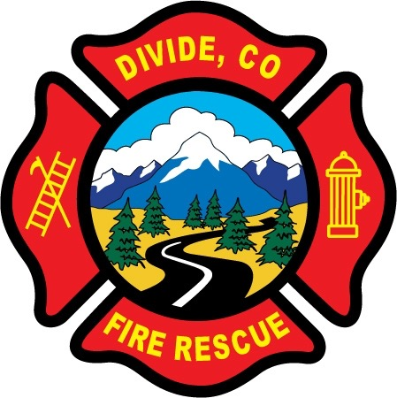

DIVIDE FIRE PROTECTION DISTRICT

Board of Directors Special Meeting

Shoemaker Fire Station, 103 Cedar Mountain Road (Mail: PO Box 941), Divide Colorado, 80814

April 18th, 2022, 5:30 p.m.

MINUTES OF THE SPECIAL MEETING

- Call to Order
President Candy Shoemaker called to order the special meeting of the Board of Directors of the Divide Fire Protection District (DFPD) at 17:41.

Board members present:
Candy Shoemaker – President
Allison Mosser – Treasurer
Barry Pleshek – Secretary
Josh Weatherill – Vice-President – present by conference call, arrived in person at 18:45.
Dennis Luttrell - Director

2. Review and Approve Agenda
The Notice has been properly posted with a copy of the Notice of Special Meeting and a copy of the Agenda. Motion by Director Luttrell to approve the agenda. Second by Director Mosser. The motion passed unanimously.

- Public Comment – none.

- Handbook – The board continued Handbook review and revisions. Changes shall be made prior to Monday, April 25th, so that the Handbook may be submitted to legal counsel for input and review.

- Adjournment

Motion by Director Luttrell to adjourn the meeting. Second by Director Weatherill. The motion passed unanimously. The meeting was adjourned at 19:32.

APPROVAL

We attest that the foregoing minutes, which have been approved by the affirmative majority vote of the Board of Directors of the Divide Fire Protection District, are a true and accurate record of the meeting held on the date stated above.

__________________________________________________ ______/______/_______
Name and Title Date

__________________________________________________ ______/______/_______
Name and Title Date

