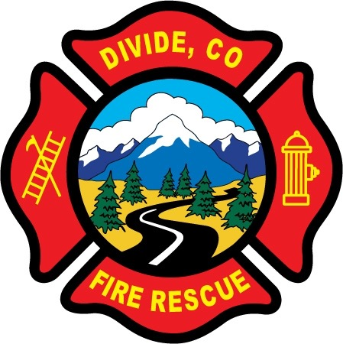

DIVIDE FIRE PROTECTION DISTRICT

Board of Directors Meeting

Shoemaker Fire Station, 103 Cedar Mountain Road (Mail: PO Box 941), Divide Colorado, 80814

December 8th, 2020 at 6:00 p.m.

MINUTES OF THE REGULAR MEETING

Special Note: Public Access was via Zoom. Notice and instructions how to access the meeting through Zoom was posted on the district website and shared through Facebook.

- Call to Order
President Shoemaker called to order the regular meeting of the Board of Directors of the Divide Fire Protection District (DFPD) at 6:04 p.m.

Attendance

Board members present:
Candy Shoemaker – President
Josh Weatherill – Vice President
Allison Mosser – Treasurer
Barry Pleshek – Secretary – present via Zoom
Dennis Luttrell – present via Zoom, left early at 7 pm

Motion by Director Shoemaker to excuse the absence of Director Luttrell at the previous meeting. Second by Director Mosser. The motion passed unanimously.

2. Review and Approve Agenda
Motion by Director Mosser to approve the agenda with that additions. Second by Director Weatherill. The motion passed unanimously.

3. Review, Approve, and Sign Minutes of Prior Meeting
Motion by Director Mosser to approve the minutes of the previous board meeting with the deletion of Director Luttrell being excused. Second by Director Weatherill. The motion passed unanimously.

4. Public Comment – None.

5. Financial Matters
A. Financial Reports – attached
B. Purchase Orders – none.
Motion by Director Weatherill to approve the financials. Second by Director Mosser. The motion passed unanimously.

Director Mosser also informed the board of the need to schedule a meeting of the Pension Board in January. Tim O’Connell was a Pension Board at-large member and has now resigned. James Wells will be taking his place along with Ryan Kennedy as Pension Board at-large members. Also, member Chuck Buckley will be retiring as of 1/1/2021, and will need to be requested by Chief Kennedy to remain as an Active Retiree at that time.

6. Chief’s Report – Attached.
A. Business Meeting Attendees – Directors Pleshek and Luttrell will attend the next business meeting on Monday, January 4th.

7. Administrator Report – attached.
A. Insurance Update – Perkins reported that auto physical damage policy cost increased $3237 primarily due to claim activity. The Board addressed the membership at the earlier business meeting to be aware of using the equipment safely and following guidelines on calls.

8. Old Business

- Policies
  - Financial Policies – The last draft of Financial Policies will be submitted to the Board for approval after legal review.

  - Updates to Handbook
    - Security Policy – Motion by Director Weatherill to adopt a resolution to add the Security Policy to the Handbook, pending legal review and assuming no substantive changes. Second by Director Pleshek. The motion passed unanimously.
    - Training/Harassment/Discrimination – Motion by Director Weatherill to adopt a resolution to update the Training Policy in the Handbook requiring certain mandatory trainings, pending legal review and assuming no substantive changes. Second by Director Mosser. The motion passed unanimously.

- Station Security – No issues during the month.

- Five Year Plan – In progress.

- Air/Light Trailer Agreement – Motion by Director Luttrell to approve the submission of the MOU to Teller County. Second by Director Weatherill. The motion passed unanimously.

- Budget
  - 2020-06 – Resolution to Certify Mill Levies – Motion by Director Weatherill to pass the Resolution to Certify Mill Levies. Second by Director Mosser. The motion passed unanimously.
  - 2020-07 – Resolution to Adopt a Budget – Motion by Director Weatherill to pass the Resolution to Adopt a Budget. Second by Director Mosser. The motion passed unanimously.
  - 2020-08 – Resolution to Appropriate Funds - Motion by Director Weatherill to pass the Resolution to Appropriate Funds. Second by Director Mosser. The motion passed unanimously.
- New Truck – Director Mosser reported on possible financing for the new truck. Rates are 2.9% for 5 years, 2.8% for 6 years, and 2.7% for 7 years. Payments will be approximately $64000.

9. New Business
A. Parking Lot Asphalt – Director Shoemaker reported an initial estimate to rework the parking lot at $135,000. It was agreed that the District should pursue grants for this project.

10. Executive Session / Employee Reviews - An Executive Session was held to discuss employee reviews and salary matters for Diana Perkins, Manuel Reyes, and Kris Babiarz, pursuant to §24-6-402(4)(f), C.R.S. Motion to enter executive session at 8:46 p.m. by Director Shoemaker. Second by Director Mosser. The motion passed unanimously. Regular session resumed at 9:19 p.m.

Motion by Director Mosser to approve the bonuses and changes to salary as communicated to Diana Perkins. Second by Director Pleshek. The motion passed unanimously.

Adjournment

Motion by Director Weatherill to adjourn the meeting. Second by Director Pleshek. The motion passed unanimously. The meeting was adjourned at 9:22 p.m. The next regular meeting will take place on Tuesday, January 12th, 2021, at 6:00 p.m.

APPROVAL

We attest that the foregoing minutes, which have been approved by the affirmative majority vote of the Board of Directors of the Divide Fire Protection District, are a true and accurate record of the meeting held on the date stated above.

__________________________________________________ ______/______/_______
Name and Title Date

__________________________________________________ ______/______/_______
Name and Title Date

