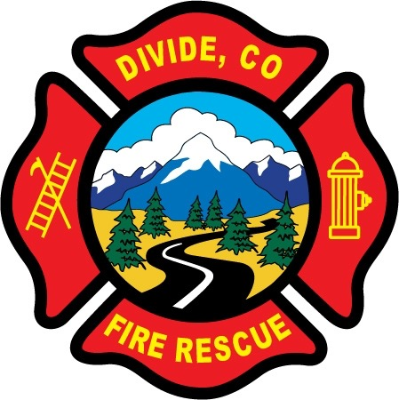

DIVIDE FIRE PROTECTION DISTRICT

Board of Directors Meeting

Shoemaker Fire Station, 103 Cedar Mountain Road (Mail: PO Box 941), Divide Colorado, 80814

July 13th, 2021 at 6:00 p.m.

MINUTES OF THE REGULAR MEETING

- Call to Order
President Candy Shoemaker called to order the regular meeting of the Board of Directors of the Divide Fire Protection District (DFPD) at 6:07p.m.

Attendance

Board members present:
Candy Shoemaker – President
Josh Weatherill – Vice President
Allison Mosser – Treasurer
Barry Pleshek – Secretary
Dennis Luttrell – Director

2. Review and Approve Agenda
Motion by Director Weatherill to approve the agenda. Second by Director Mosser. The motion passed unanimously.

3. Review, Approve, and Sign Minutes of Prior Meeting
Motion by Director Luttrell to approve the minutes of the previous board meeting. Second by Director Weatherill. The motion passed unanimously.

4. Public Comment – None.

5. Financial Matters
A. Financial Reports – attached. Motion by Director Mosser to approve the financials and pay bills. Second by Director Weatherill. The motion passed unanimously.
B. Purchase Orders – 2021-07 PC Touchup – $479.99 Replace battery backup
2021-08 VFA Grant Items - $11054.45
Motion by Director Mosser to approve the purchase orders. Second by Director Pleshek. The motion passed unanimously.
C. Audit – Diana Perkins reported that due to staffing issues the audit will not be submitted for approval until later in the month. Due to the July 31st deadline for the audit to be submitted to the state, Director Pleshek made a motion to approve the audit contingent upon a review by Treasurer Allison Mosser finding no significant issues. Second by Director Weatherill. The motion passed unanimously.

6. Chief’s Report – attached.
A. Radios - Update on 800 mHz radios: DFPD is supposed to receive 12 mobiles free from the county, and another 8 handhelds that we have already been invoiced $14,000 for. Toneguard will be needed to avoid too much radio noise. This might occur in August or later.

A. Business Meeting Attendees – Director Weatherill will attend the August 2nd business meeting with Director Luttrell as backup.

7. Administrator Report – attached. Diana Perkins submitted a revised job description for Emergency Response Support. Director Luttrell made a motion to accept the revised job description and appoint Manuel Reyes to the position. Second by Director Mosser. The motion passed unanimously. The position will be reviewed by the board again at the October board meeting. Perkins also brought up the issue of not having enough authorized service shops for the department vehicles. The board considered sending a letter to the Teller County Board of Commissioners to make them aware of the issue. Diana Perkins will work with Manuel Reyes to create a list of vehicles and service sources for the board to review.

8. Old Business

- Policies
  - Updates to Handbook – Ireland Stapleton is still working on this project. Director Weatherill forwarded information to Diana Perkins to get a quote from Lexipol.

- Station Security – No reports of security issues.

- Air/Light Trailer Agreement – Director Luttrell forwarded a draft of the letter to Candy Shoemaker shortly before the meeting. Director Shoemaker will forward to the other board members for review.

9. New Business
A.

10. Executive Session – none.

Adjournment

Motion by Director Mosser to adjourn the meeting. Second by Director Weatherill. The motion passed unanimously. The meeting was adjourned at 7:34 p.m. The next regular meeting will take place on Tuesday, August 10th, at 6:00 p.m.

APPROVAL

We attest that the foregoing minutes, which have been approved by the affirmative majority vote of the Board of Directors of the Divide Fire Protection District, are a true and accurate record of the meeting held on the date stated above.

__________________________________________________ ______/______/_______
Name and Title Date

__________________________________________________ ______/______/_______
Name and Title Date

